Nepal College of information Technology
Imadol lalitpur
Unit Test Spring Semester 2006

Program : BE/BCIS Semester: Spring
Time : 2hrs Year : 2006
Full Marks: 60
Electronic Device

1 a) What do u mean by a piecewise linear modeling of a diode? Find i and V_{s} for the circuit given below. 7
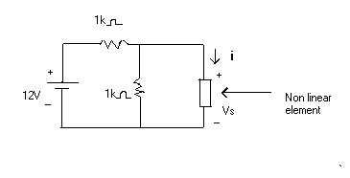
Assume i = A (V_{s} –V_{TR})² where A= 1mA/V² and V_{TR}= 0V
b) Distinguish between general PN junction diode and Schottky diode .With the help of necessary circuit diagram and waveform; explain reverse recovery time of PN junction Diode. 8
2 a) Define space charge (transition) capacitance of a P-N junction diode. Show that expression for transition capacitance is similar to capacitance of parallel plate Capacitor, given by C_{T} = εA/W 7
b) Determine the range of Zener Current( I_{Z} ) that will be maintained across the diode when input supply vary between 60- 110 V in the Figure below. 8

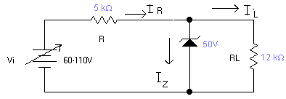

3) a Derive the expression for collector and Emitter current for CE configuration. How β (Base current amplification Factor) relate to α. 7
b.) What is early effect ? Discuss its consequences when transistor is operated in Active region. Draw the input and output characteristic curves of CB configuration. How Early effect affects the shape of the respective curves? 8
4 a) What are the disadvantages of Center-tap full-wave rectifier. Draw Full wave(central tap) rectifier circuit neglecting forward voltage drop across forward biased diode, sketch the waveform for input voltage, output voltage and voltage across diodes 7
b) Considering diode as ideal, sketch V_{out} for the circuit shown below. 8
